**EXPERIMENT-10**

**AIM OF EXPERIMENT: Write a java program of MINMAX and ROUND ROBIN TASK SCHEDULING ALGORITHM using CLOUDSIM PLATFORM.**

Q1) WRITE JAVA PROGRAM OF ROUND ROBIN TASK SCHEDULING ALGORITHM USING CLOUDSIM

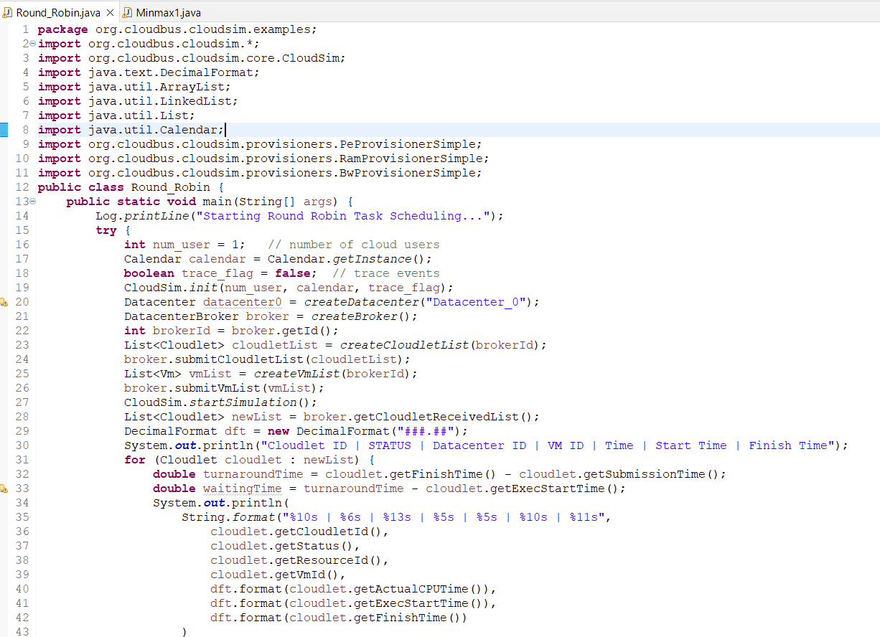

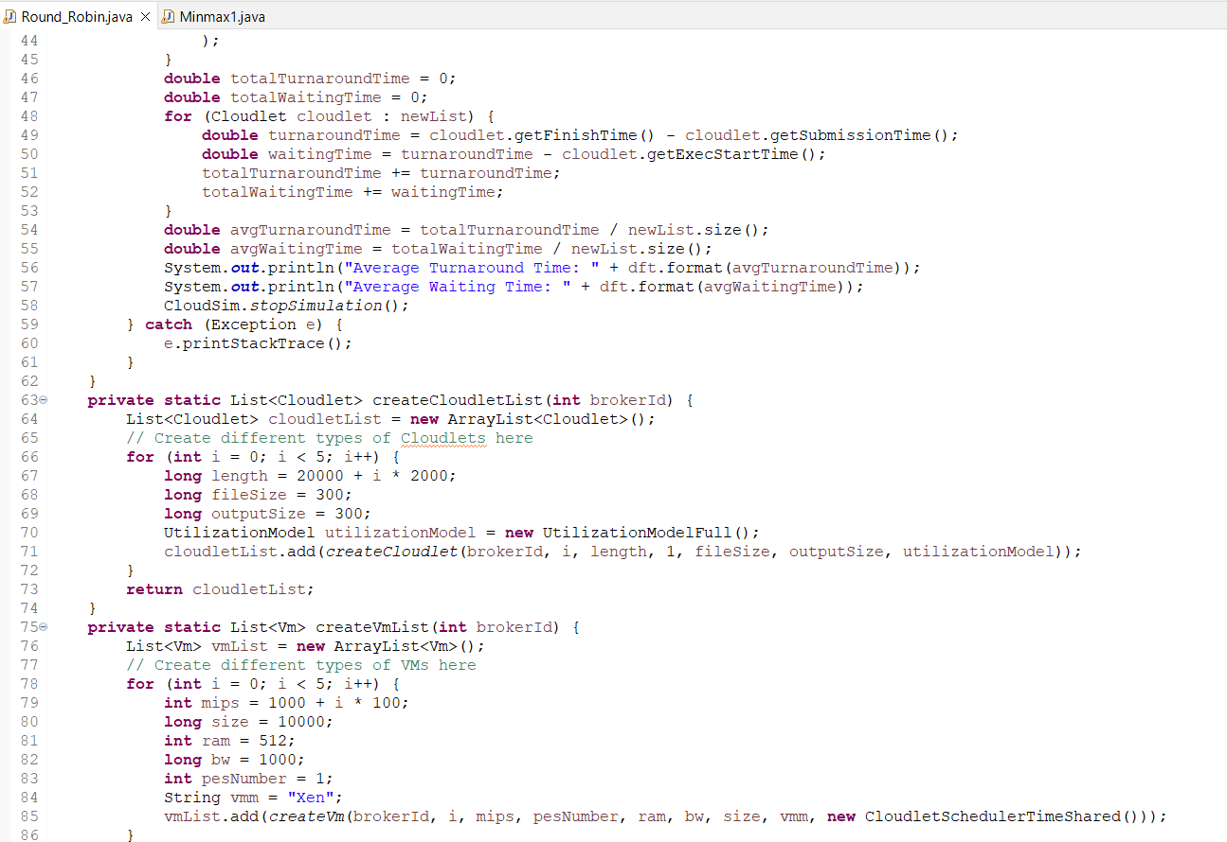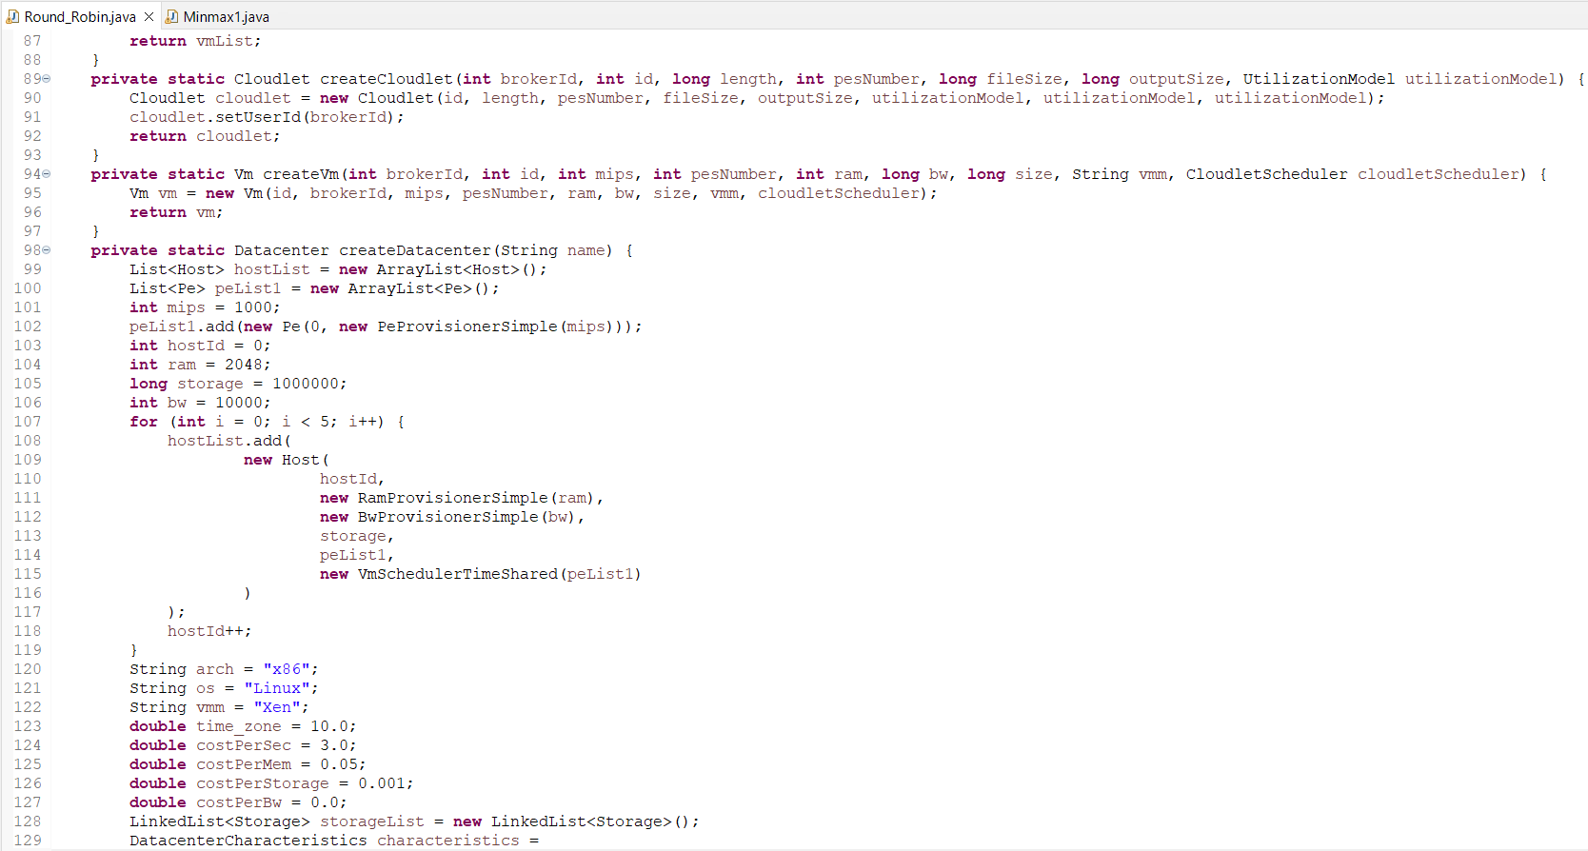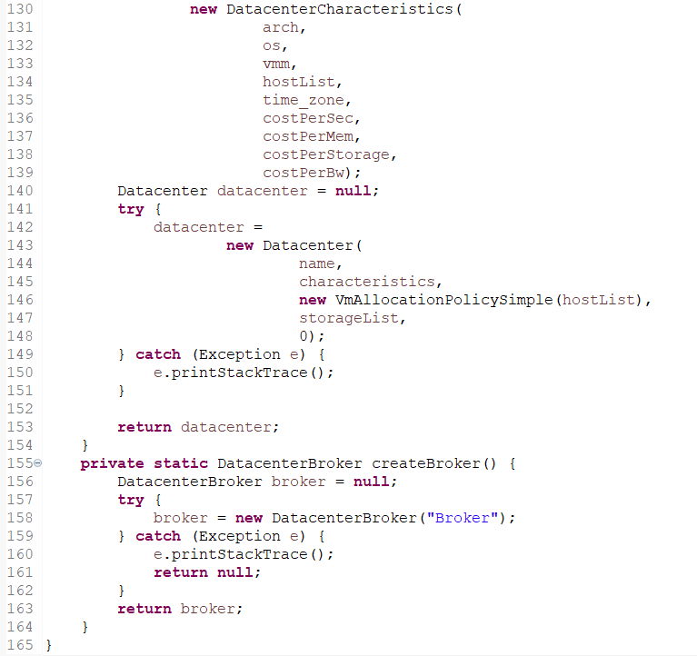

**OUTPUT:-**

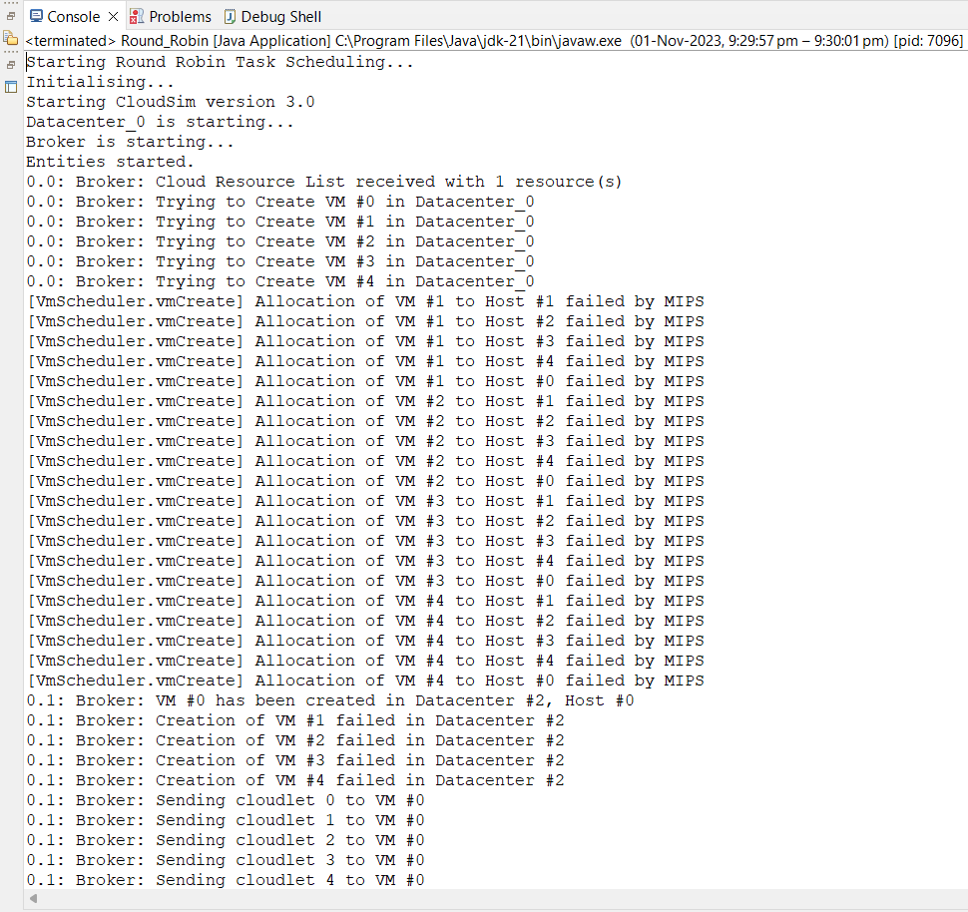

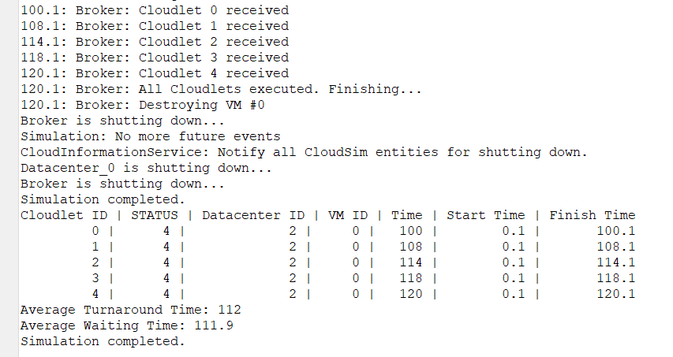

Q2) WRITE MINMAX JAVA PROGRAM USING CLOUDSIM

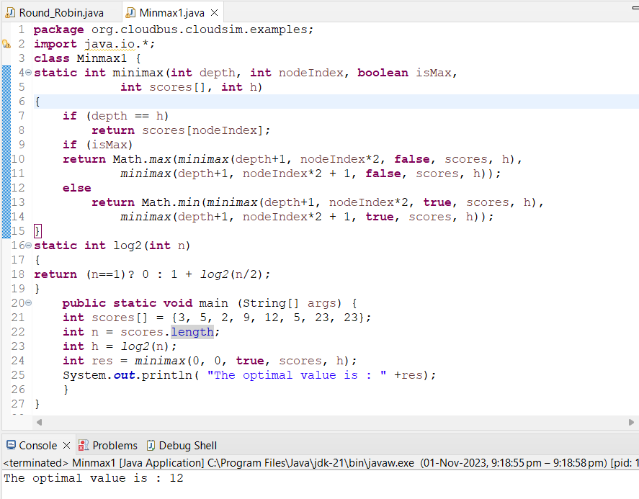

**SUBMITTED BY**

|  |  |
| --- | --- |
| NAME | UJJWAL KUMAR BHADANI |
| REGD NO. | 2101020286 |
| GROUP | 4 |
| SEM | 5TH |